

Adobe Experience Platform

Data Pipeline

# Lab Overview

Ingest Customer Accounts data into AEP in batch mode using Data Landing Zone. This Lab will leverage delimited data on Landing Zone and ML Recommendations to map most of the source data. This job will be scheduled to run every 7 days.

This lab will introduce you to customizing the ML recommendations in Data Prep and updating manual mappings.

**Expected time: 30 minutes**

# Learning Objectives

What should you walk away with after taking this Lab?

* Adding pass through mappings
* Using preview to check any data quality issues
* Address basic data quality issues using Calculated Fields

# Lab Tasks

In this exercise, we will load the Customer Account data from Data Landing Zone to AEP Data Lake and Profile.

**Pre-requisites**

1. Customer Account JSON file uploaded in the Azure ADLS Directory
2. Customer Account Schema and Dataset are already created

## Select Source data

Go to Adobe Experience Platform à **Sources** à **Catalog** à **Cloud storage**. Click on **Setup** / **Add Data** for the Data Landing Zone.

|  |  |
| --- | --- |
| Tip | If at least one connection exists for that source, you will see “**Add data**” as the default action. If no connections exist for that source, you will see “**Setup**” as the default action. |

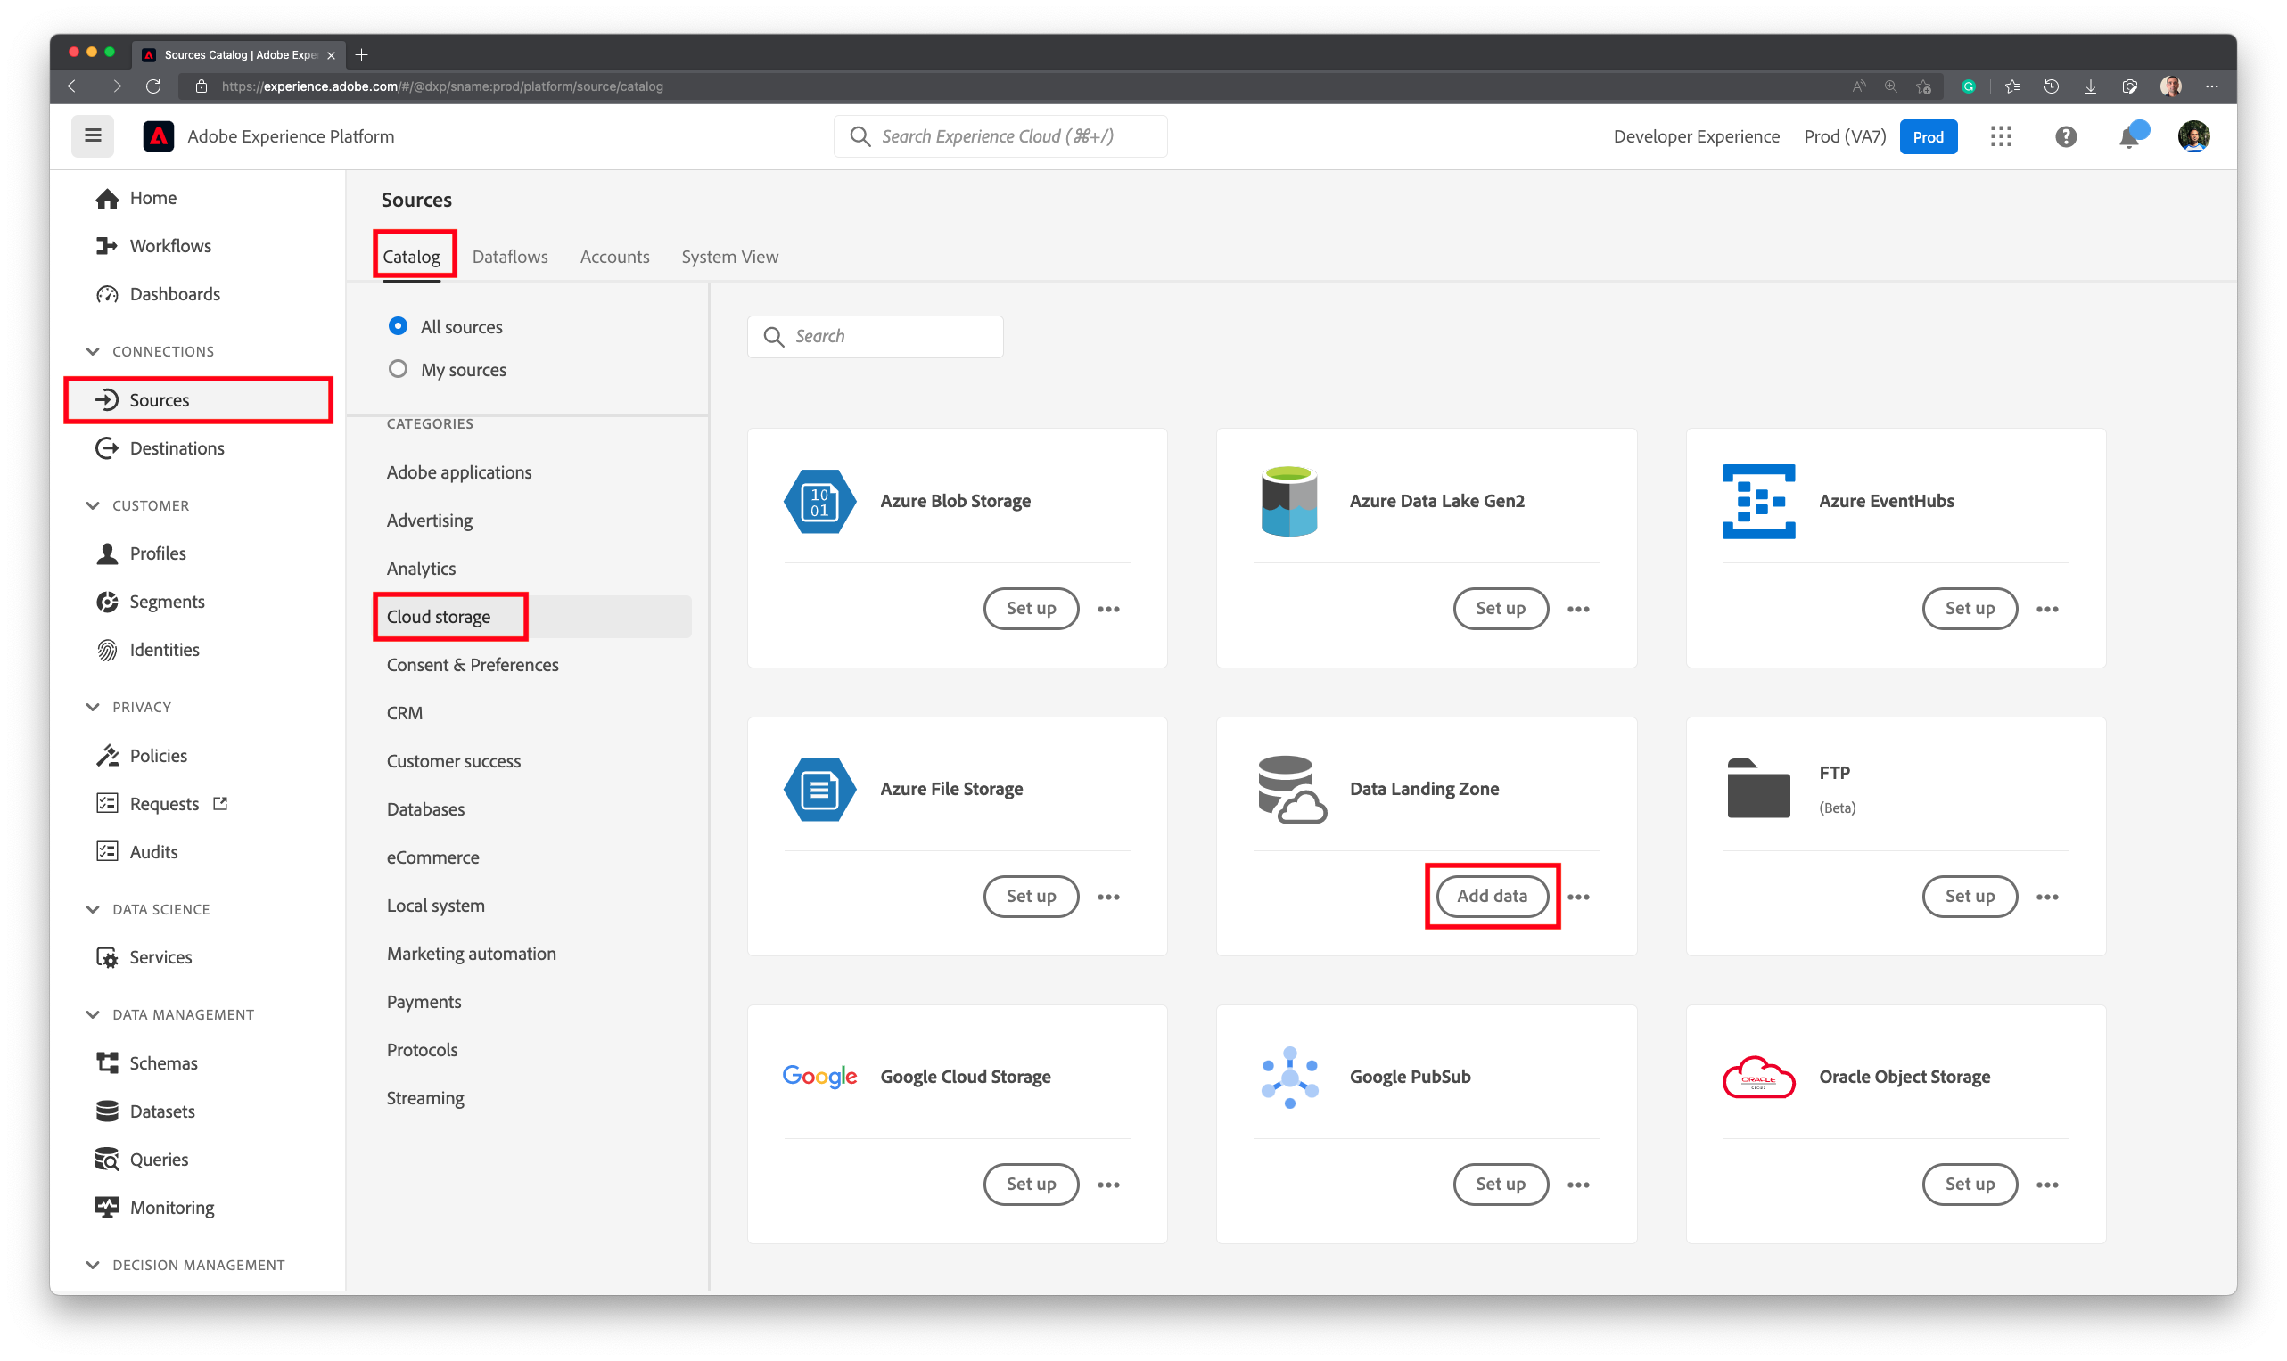

In the **Select data** screen, choose **Lab_Customer.csv**, at the location **/dlz-user-container/project/PIPELINE**. On the right hand side, choose the **Delimiter** as the **Data format** and comma (**,**) as **Delimiter** and **compression type** as **None** (default)

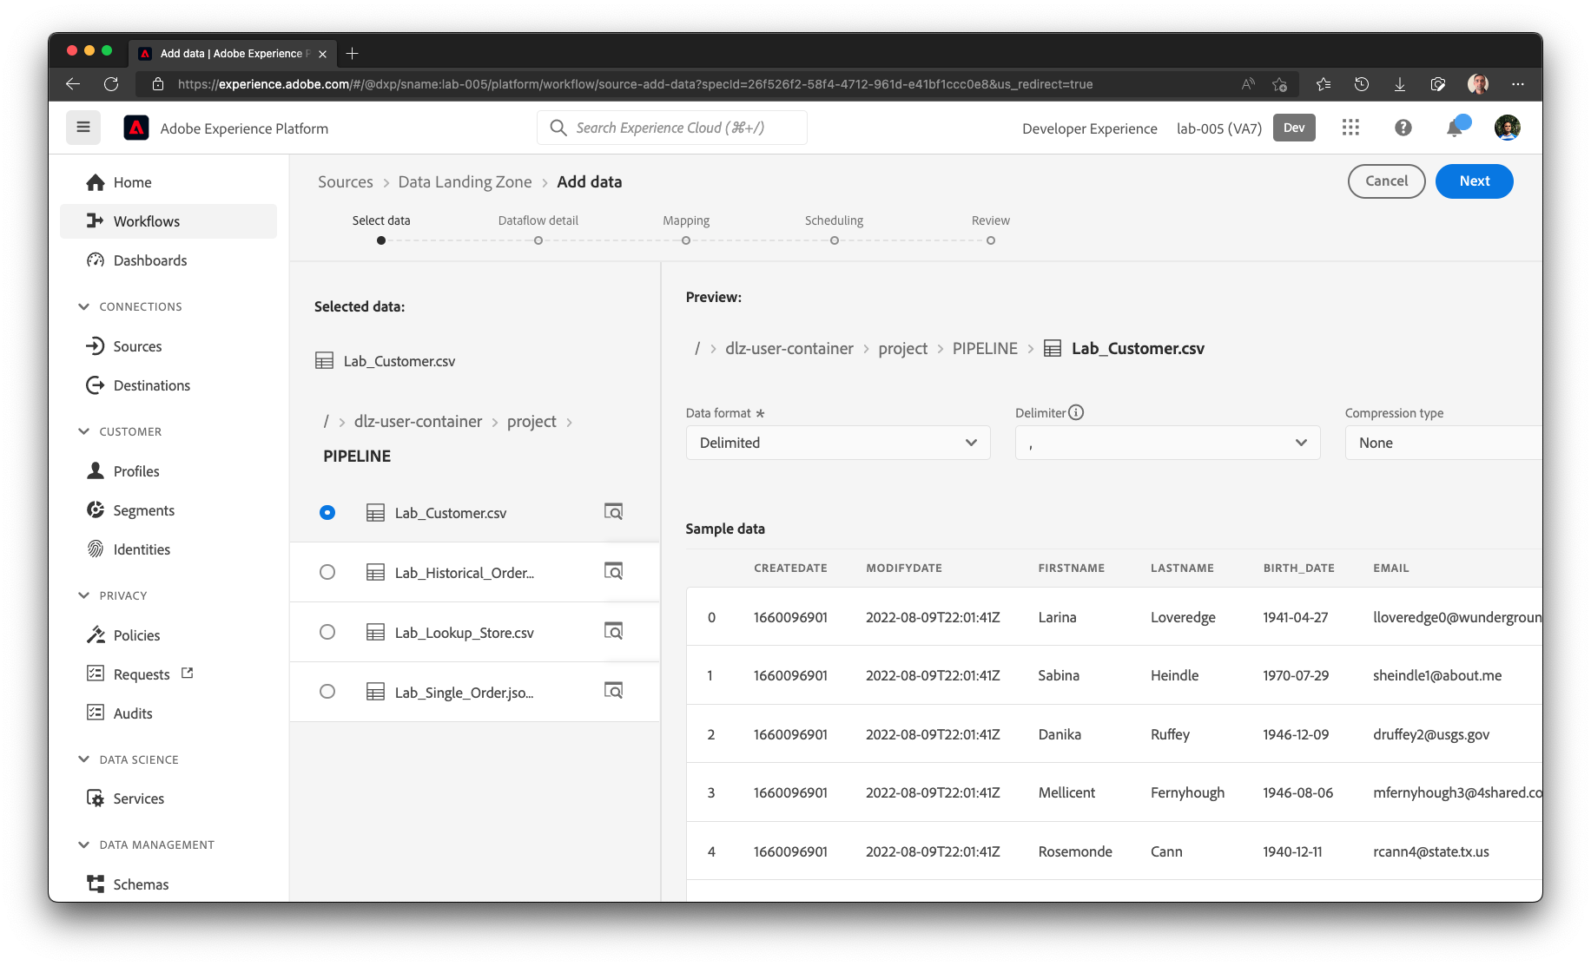

In the preview here, notice the following attributes:

* **sms_optIn** has null values (shown in preview as - )
* **account_create_date** has string values along with date and time values. **account_end_date** has proper date format.

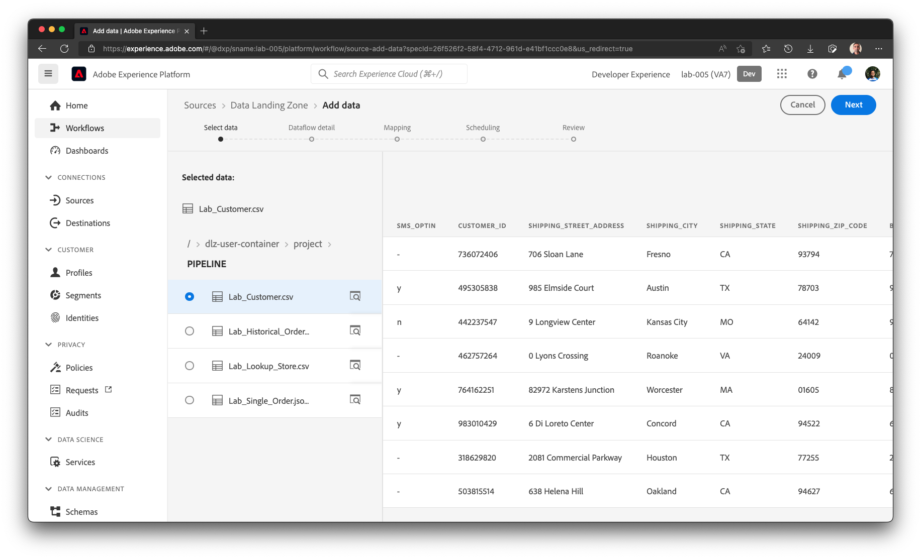

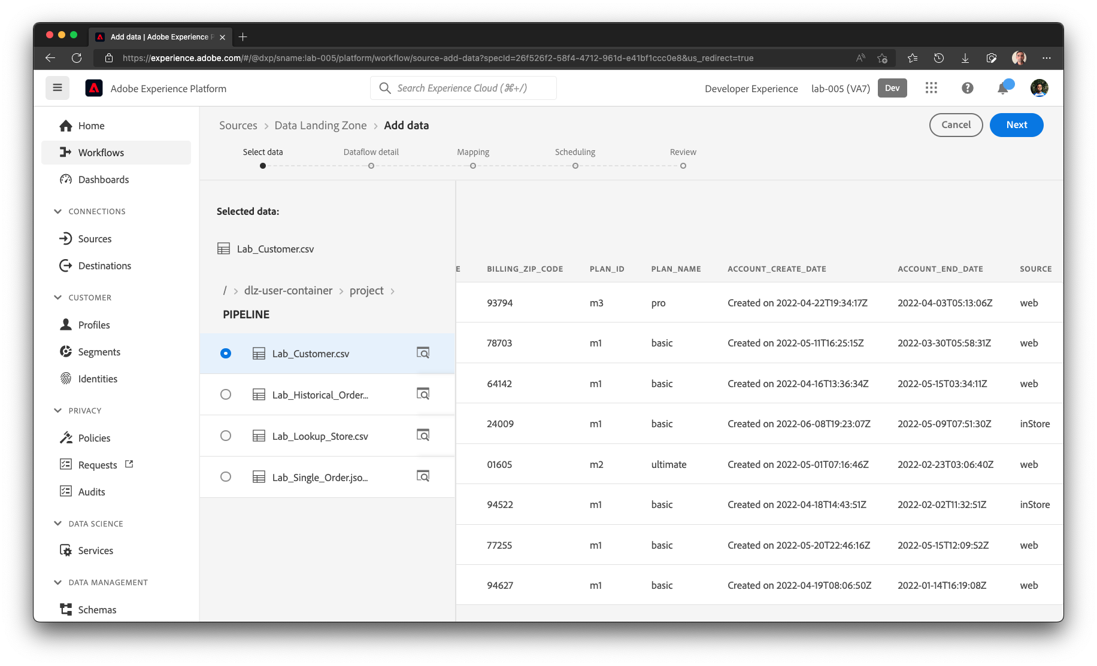

## Define the Target Dataset

In the **Dataflow detail** screen, choose **New dataset**. Name the output dataset as **dep:Customer Account**. Select the schema name **Customer Account Creation**. Turn ON the **Enable partial ingestion**. Set the Dataflow name as **Dataflow - Customer Account**. Click **Next** to continue.

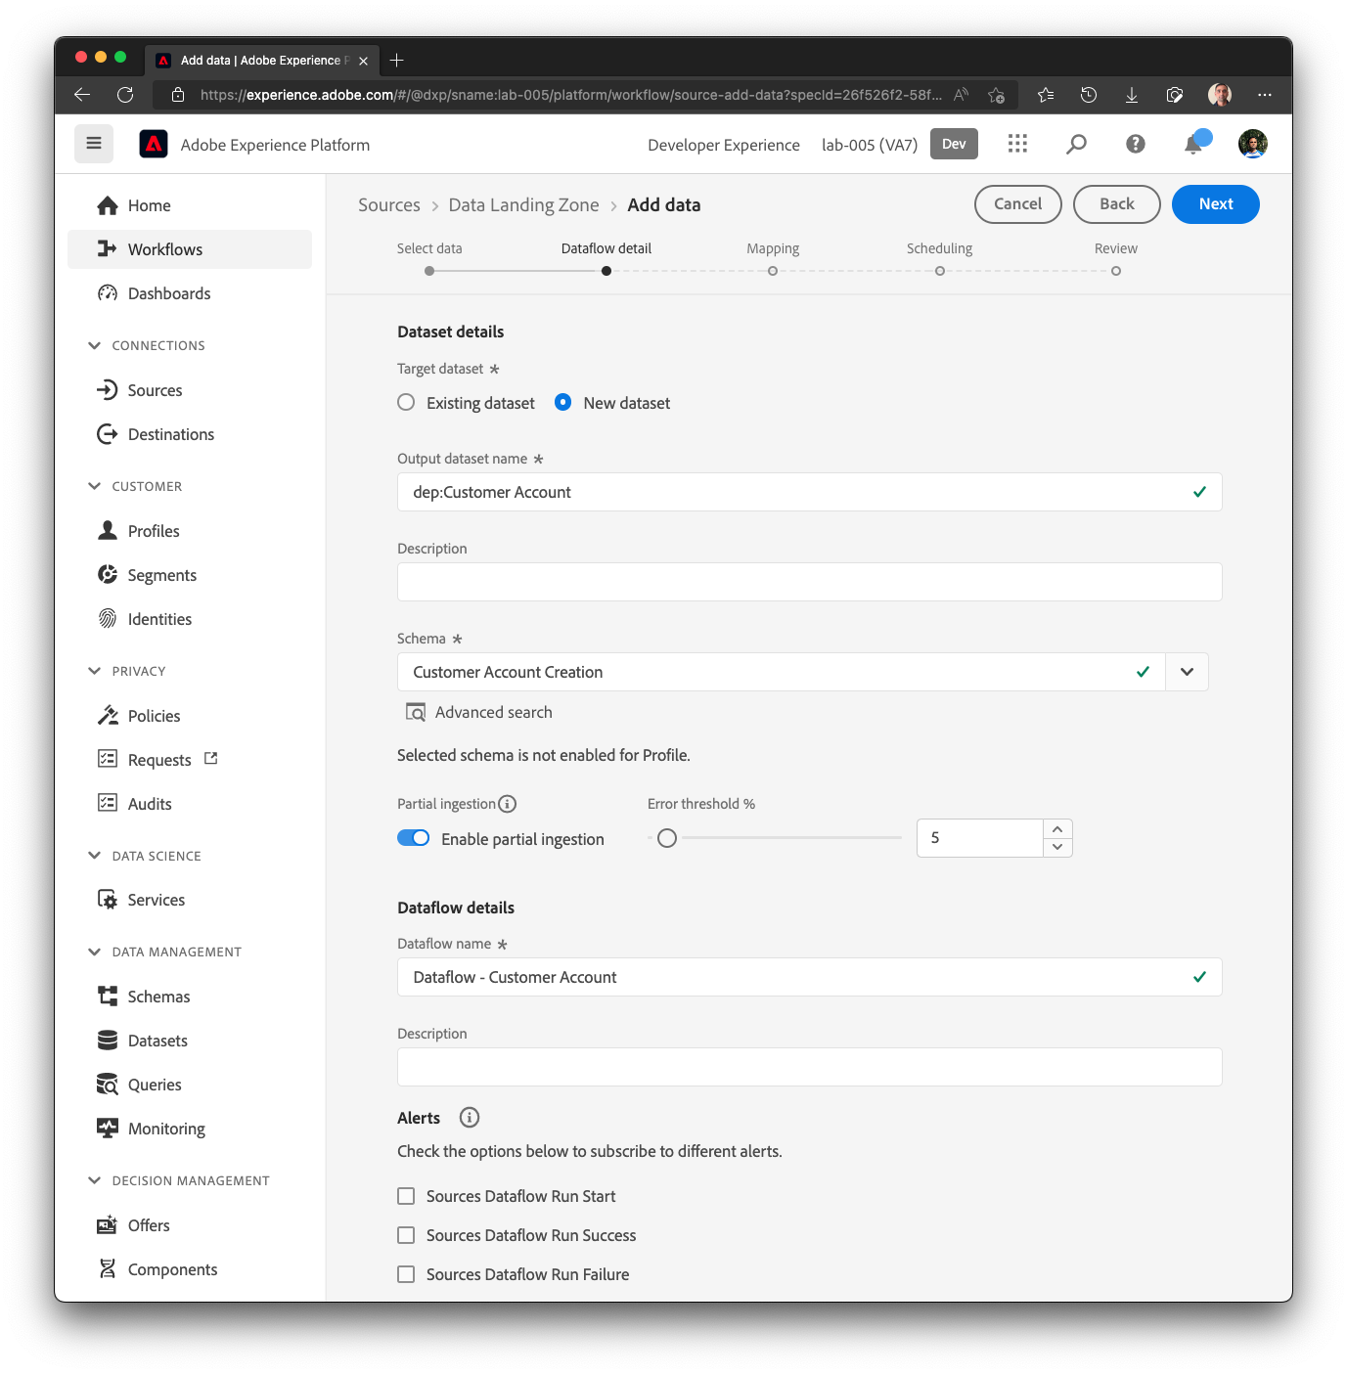

## Data Prep / Transformation

In the **Mapping** screen, Recommendation engine will map several attributes automatically. However, there will be some errors that need to be addressed before moving on to next step.

The initial screen will look like this

|  |  |
| --- | --- |
| Warning | Due to the ML Recommendations, your screen may look different than the screenshot below. |

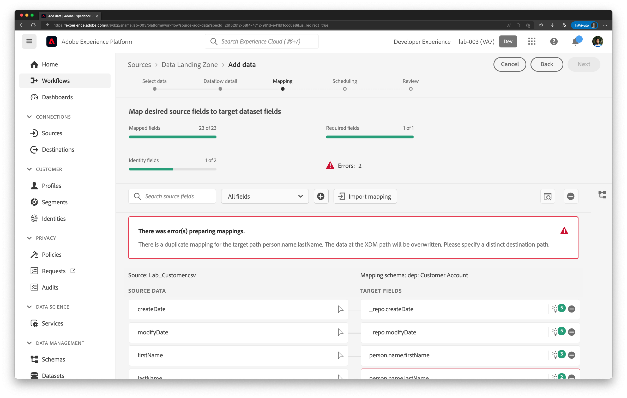

## Preview the mapping output

### SMS Opt In

Preview the mapping output by clicking  In Preview screen, navigate to the **consents.marketing.sms.val** attribute and you will see red exclamation showing the error. Notice that there are null values (shown as – in the preview)

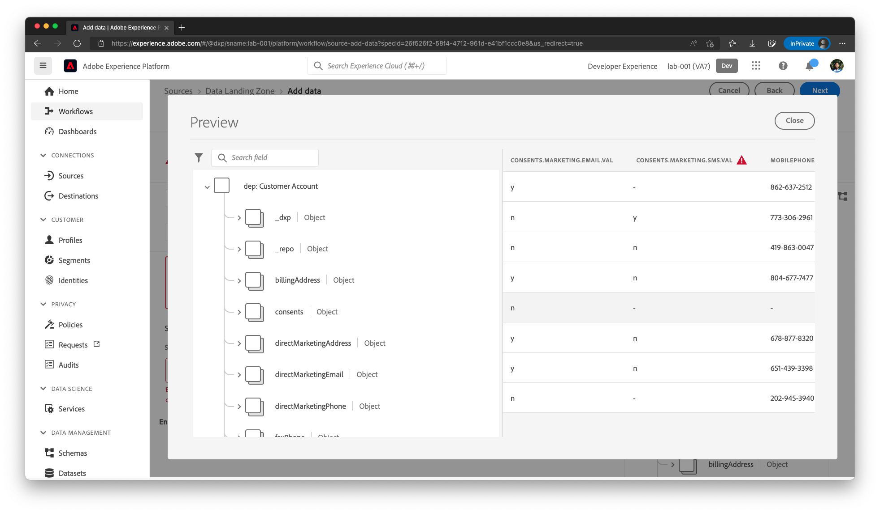

**NOTE:**

At runtime, Data Prep will “localize” all transformation errors to the column (unless the column is a required field). During design time, Data Prep is more stringent to catch any data issues. In the sample data provided, **sms_optIn** has NULL values as seen in the preview screen earlier. Hence the system is reports it as an error and requires Data Engineer to address that scenario before proceeding further.

### Account Create Date

In Preview screen, navigate to the **_dxp.account.createDate** . It is showing as NULL even though the source has value. This is because the data contains string values such as “**Created on 2022-06-04T19:2409Z**” as the timestamp and hence we are unable to successfully convert the date properly.

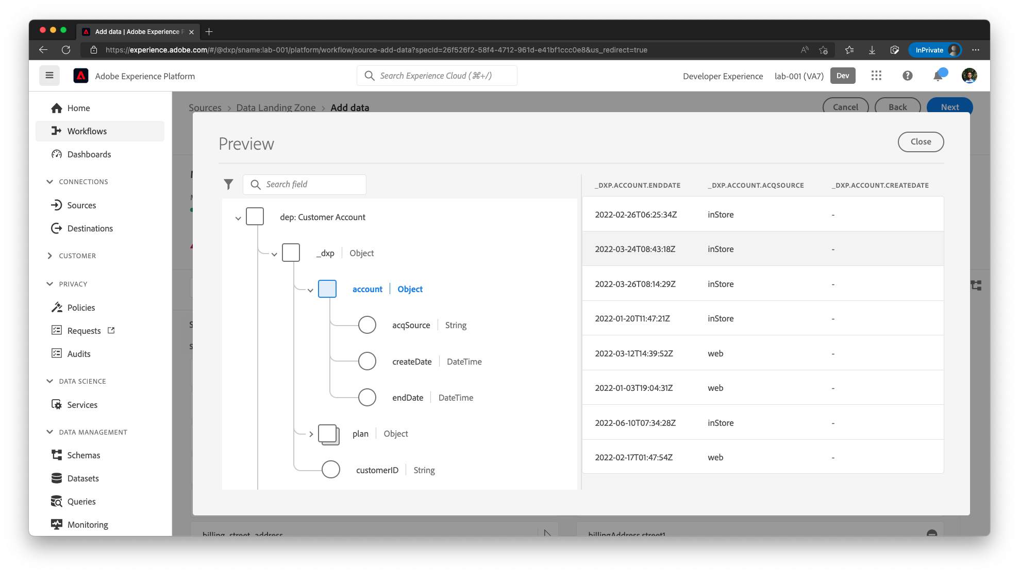

We will NOT fix this error as we will use to understand how Data Prep / Mapper errors are reported later.

|  |  |
| --- | --- |
| TIP | Note that the input file is CSV and all attributes are Strings. Data Prep automatically recognized the date attributes such as account_end_date and converted them into date. Similarly, Zip Code is automatically converted into number. |

## Re-map the attributes

When you scroll down, you will notice **plan_name** mapped to **person.name.lastName** (or some other invalid attribute). Click on the target name and choose the **_dxp.plan.planName**.

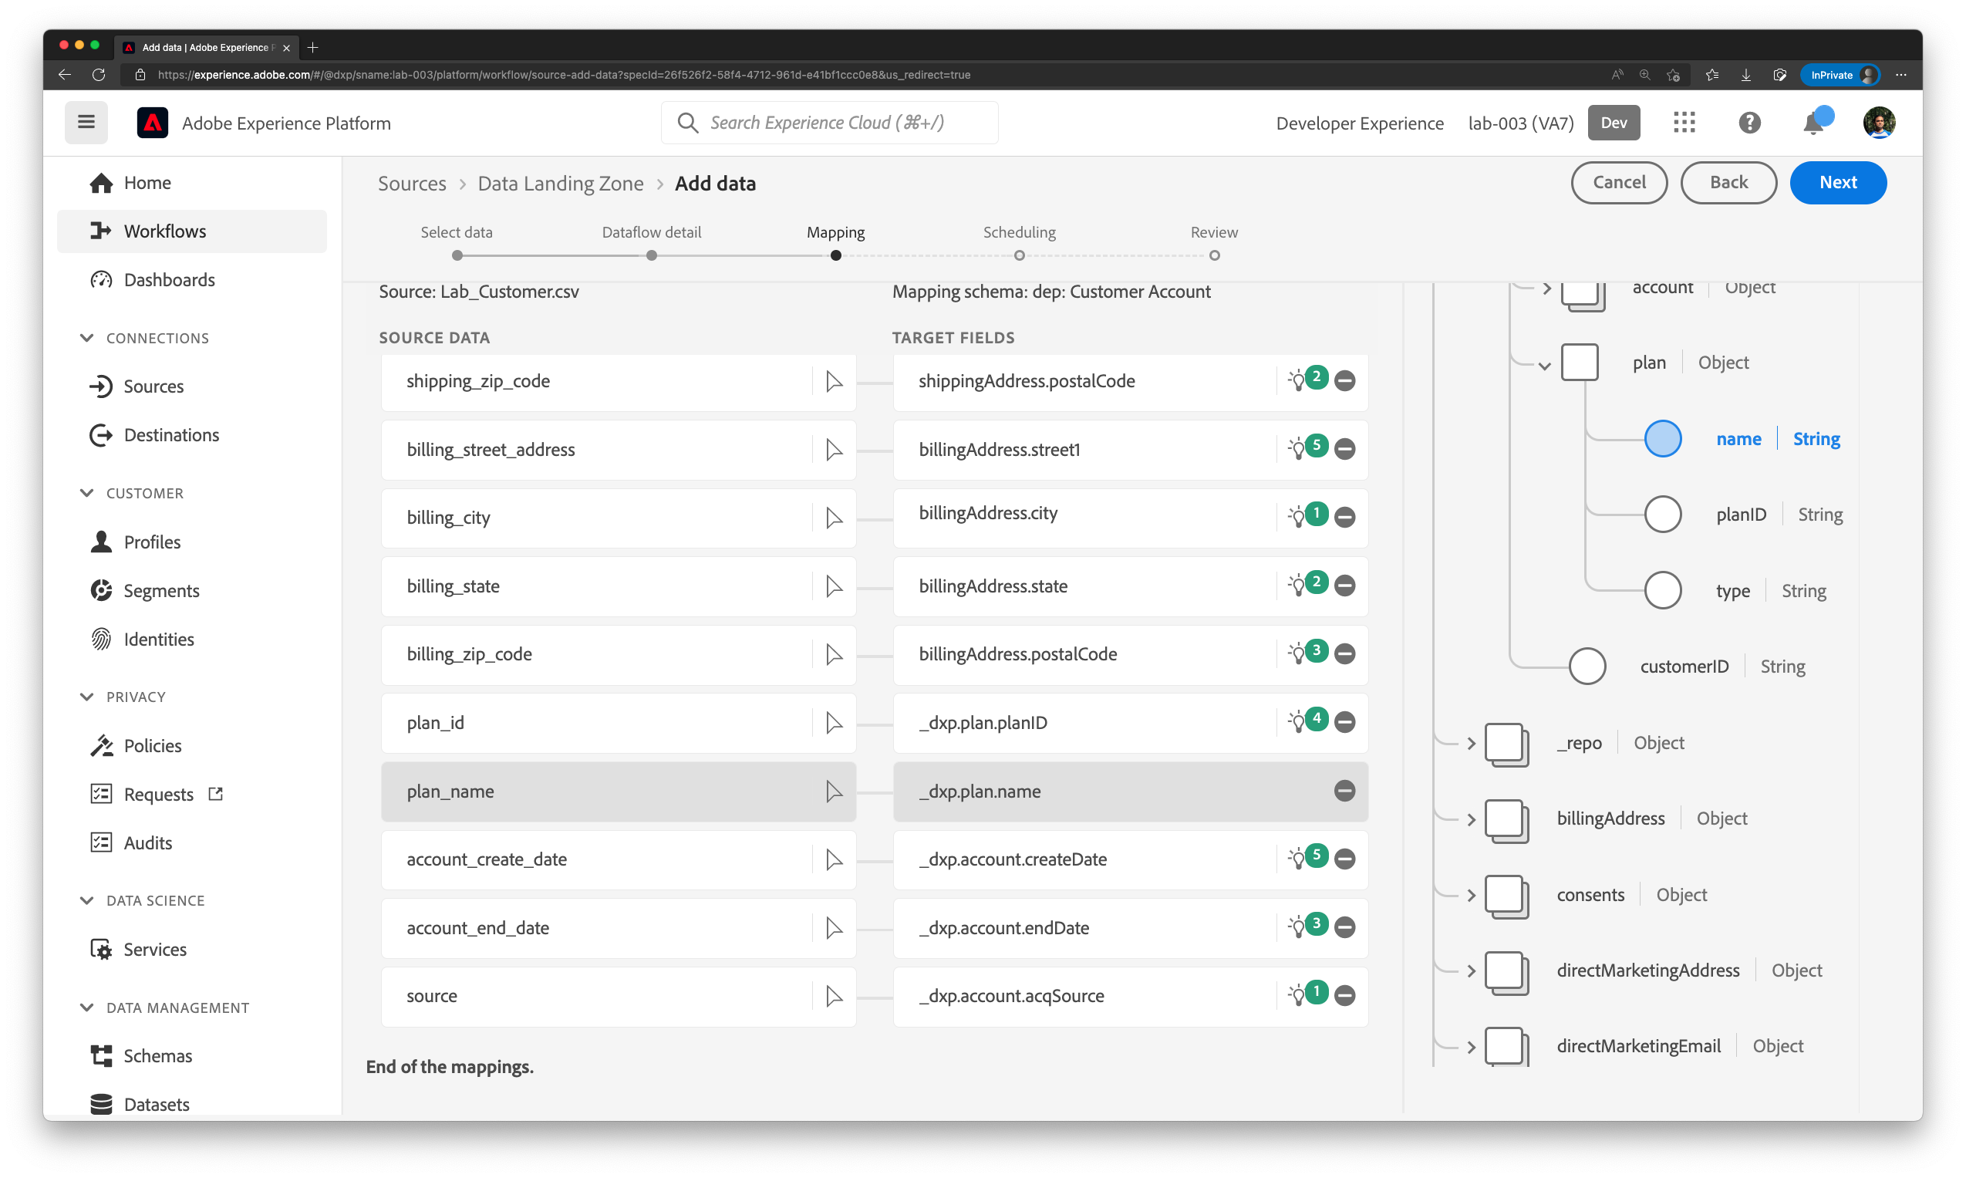

Similarly, Change the mappings as necessary to match the table below

| Source Column | XDM Property |
| --- | --- |
| customer_id | _dxp.customerID |
| first_name | person.name.firstName |
| last_name | person.name.lastName |
| email | personalEmail.address |
| mobile_phone | mobilePhone.number |
| billing_street_address | billingAddress.street1 |
| billing_city | billingAddress.city |
| billing_state | billingAddress.state |
| billing_zip_code | billingAddress.postalCode |
| shipping_street_address | shippingAddress.street1 |
| shipping_city | shippingAddress.city |
| shipping_state | shippingAddress.state |
| shipping_zip_code | shippingAddress.postalCode |
| email_optIn | consents.marketing.email.val |
| account_create_date | _dxp.account.createDate |
| account_end_date | _dxp.account.endDate |
| plan_id | _dxp.plan.planID |
| plan_name | _dxp.plan.name |
| create_date | repo.createDate |
| last_modified | repo.modifyDate |
| source | _dxp.account.acqSource |

## Calculated Fields

### SMS Opt In

Scroll down to **sms_optIn**, and remove the mapping.

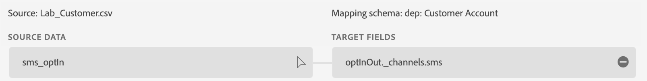

Now create a calculated field by clicking 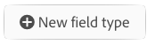 icon(sometimes shown as 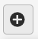) 🡪 **Add Calculated Field**. In the Create Calculated field dialog box write the following expression and hit **Preview**.

|  |
| --- |
| **iif(sms_optIn == null, 'n', sms_optIn)** |

You should see a green checkmark in the top right corner of the black box indicating the validity of the expression and the data Preview should only show “n” or “y” as values. Then click **Save**.

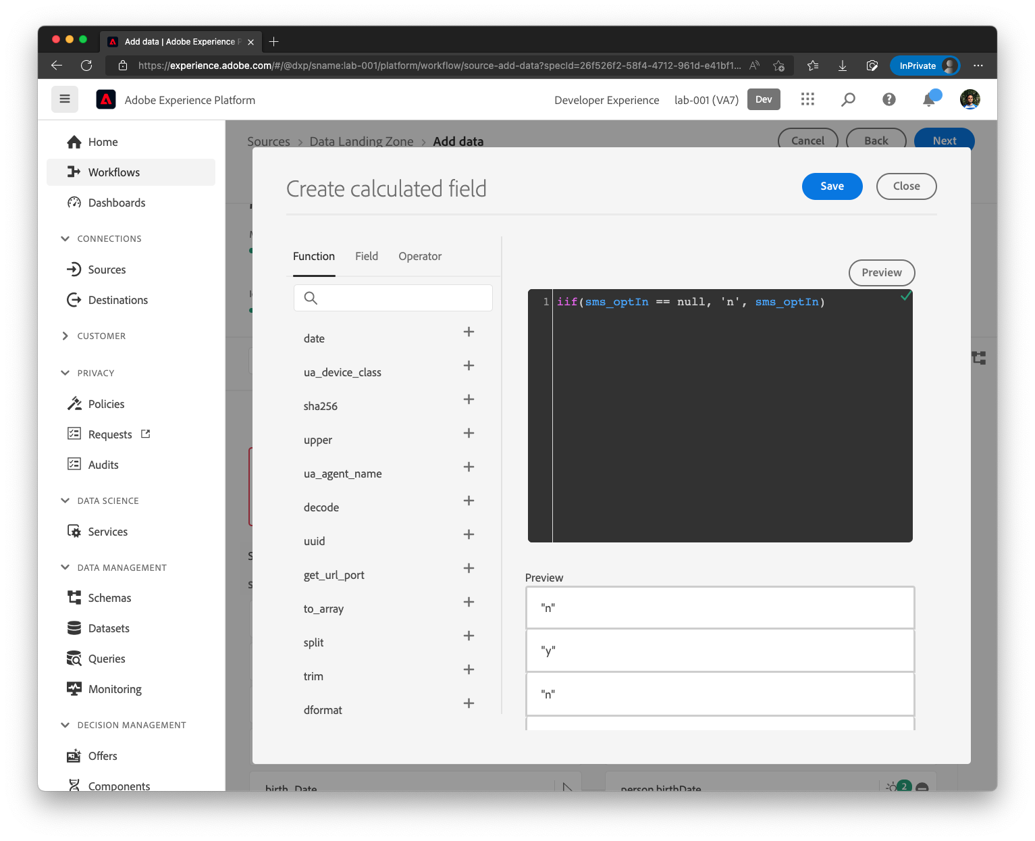

The mapping will now look like this

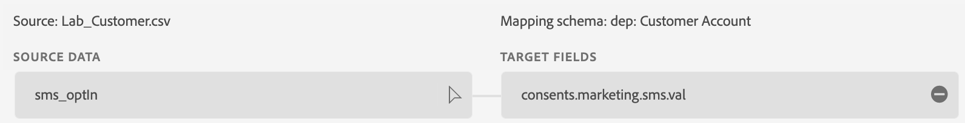

### Birth Dates

Remove the mappings for **birth_date** source field by clicking (-) icon at the end of the row.

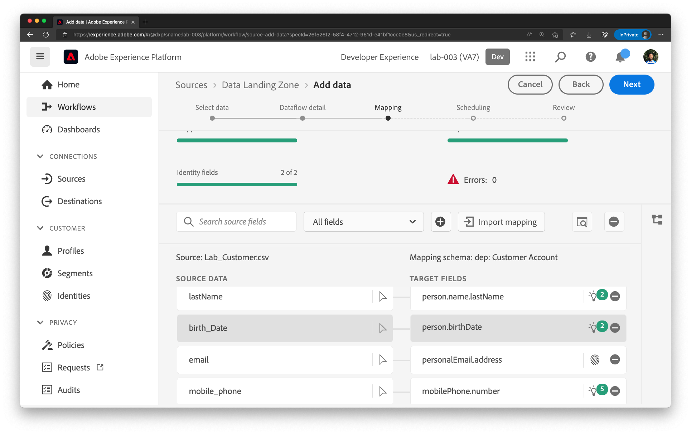

Add a Calculated Field by clicking the (+) icon and **Add Calculated Field**. Type in the following expression into the calculated field

|  |
| --- |
| **date_part("year", date(birth_Date))** |

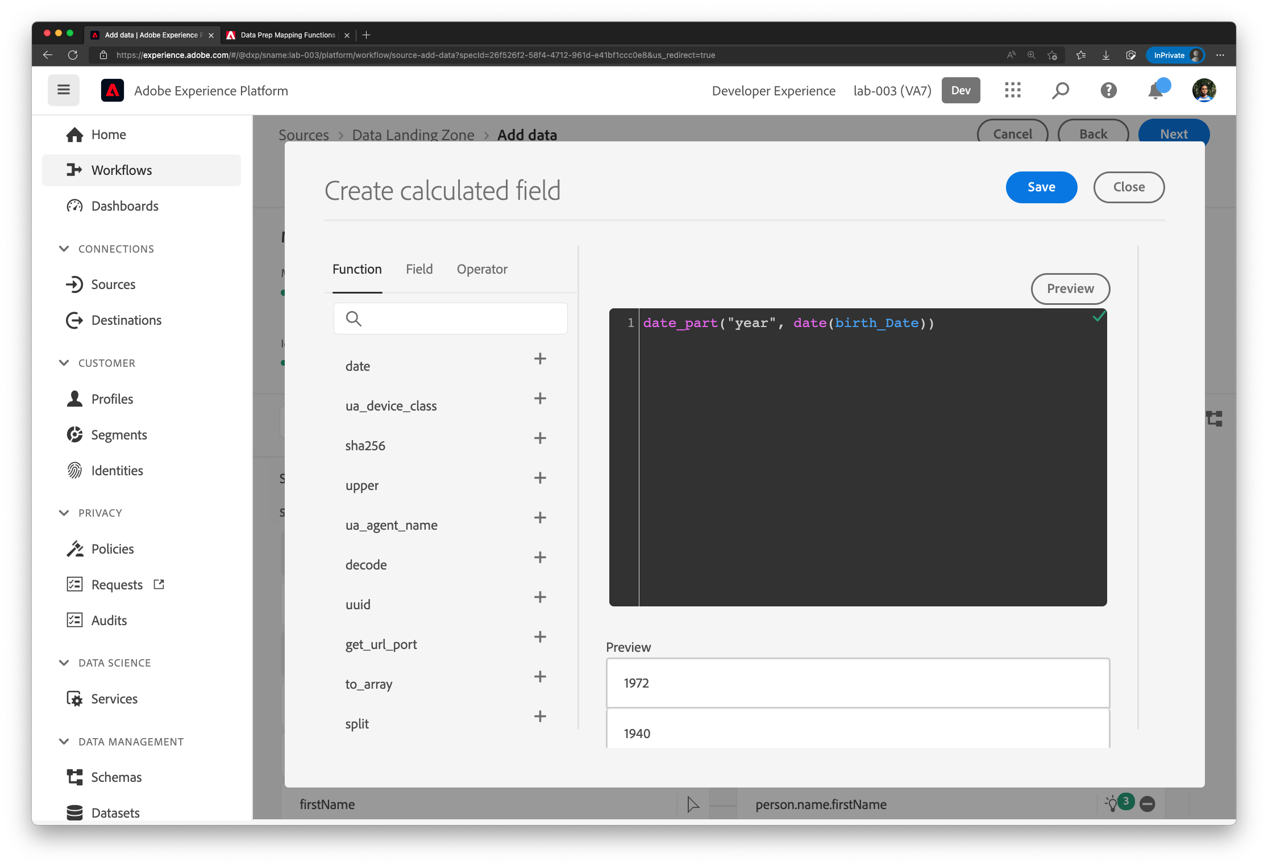

Click Save to save this expression and map it to **person.birthYear**

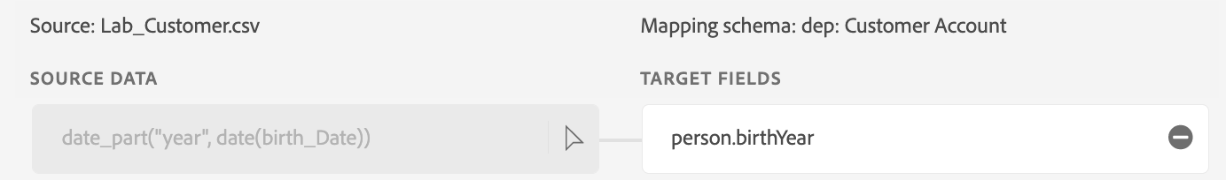

Add another calculated field with the following expression and map it to **person.birthDayAndMonth**

|  |
| --- |
| **concat(**  **date_part("month", date(birth_Date)),**  **"-",**  **date_part("dd", date(birth_Date))**  **)** |

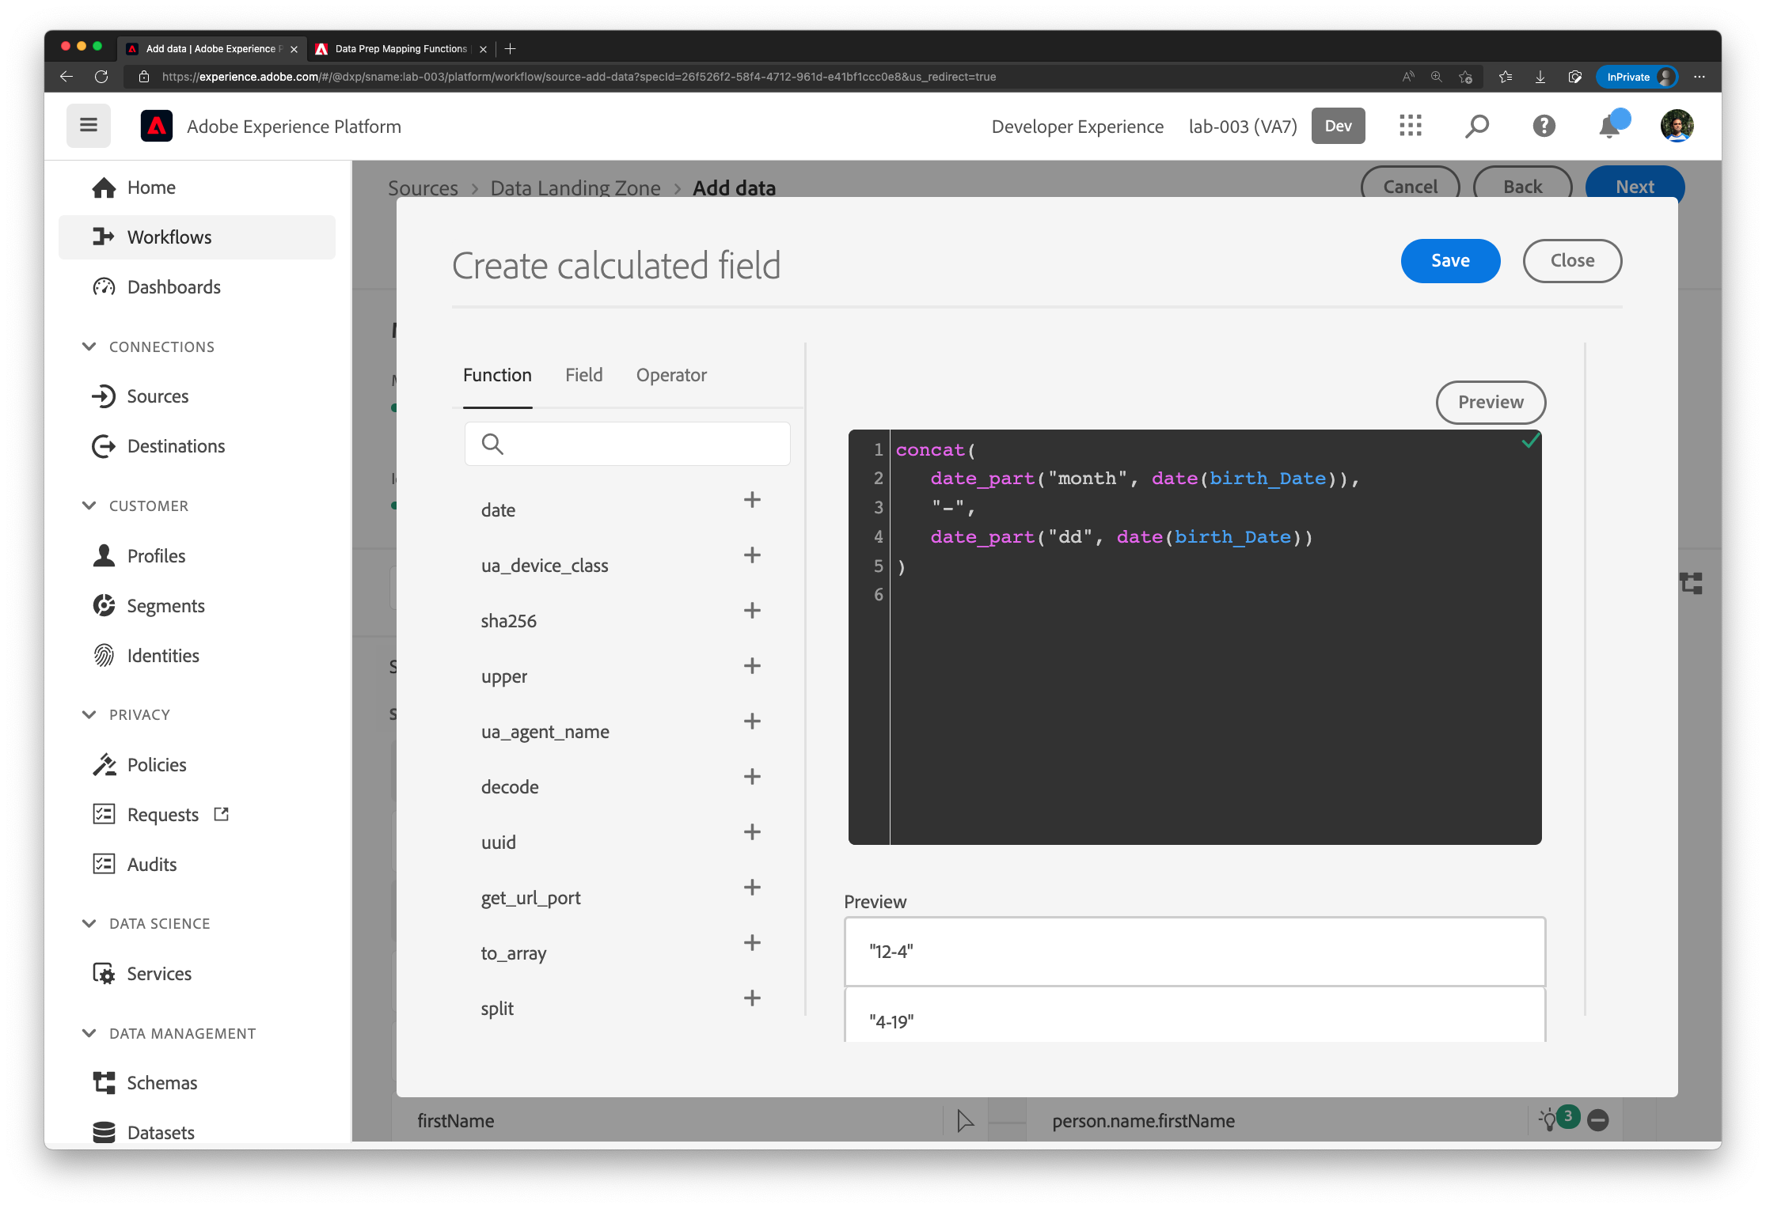

The mapping will now look as below.

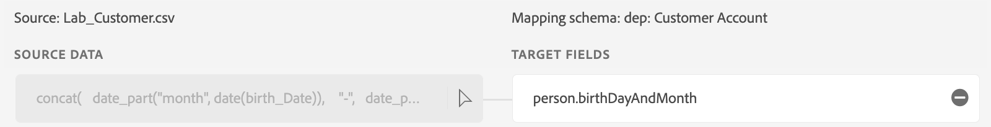

### Final Mapping Set

The final mapping set looks like below

| Source Column | XDM Property |
| --- | --- |
| source | _dxp.account.acqSource |
| account_create_date | _dxp.account.createDate |
| account_end_date | _dxp.account.endDate |
| customer_id | _dxp.customerID |
| plan_name | _dxp.plan.name |
| plan_id | _dxp.plan.planID |
| billing_city | billingAddress.city |
| billing_zip_code | billingAddress.postalCode |
| billing_state | billingAddress.state |
| billing_street_address | billingAddress.street1 |
| email_optIn | consents.marketing.email.val |
| mobile_phone | mobilePhone.number |
| first_name | person.name.firstName |
| last_name | person.name.lastName |
| email | personalEmail.address |
| create_date | repo.createDate |
| last_modified | repo.modifyDate |
|  |  |
| shipping_city | shippingAddress.city |
| shipping_zip_code | shippingAddress.postalCode |
| shipping_state | shippingAddress.state |
| shipping_street_address | shippingAddress.street1 |

|  |  |
| --- | --- |
| Calculated fields | |
| iif(sms_optIn == null, 'n', sms_optIn) | consents.marketing.sms.val |
| concat(  date_part("month", date(birth_Date)),  "-",  date_part("dd", date(birth_Date))  ) | person.birthDayAndMonth |
| date_part("year", date(birth_Date)) | person.birthYear |
|  |  |

## Schedule

In the **Scheduling** step, set the **Frequency** to **Day** and **Interval** to **7** and leave the **Backfill** turned on. This will schedule the Dataflow to run every 7 days

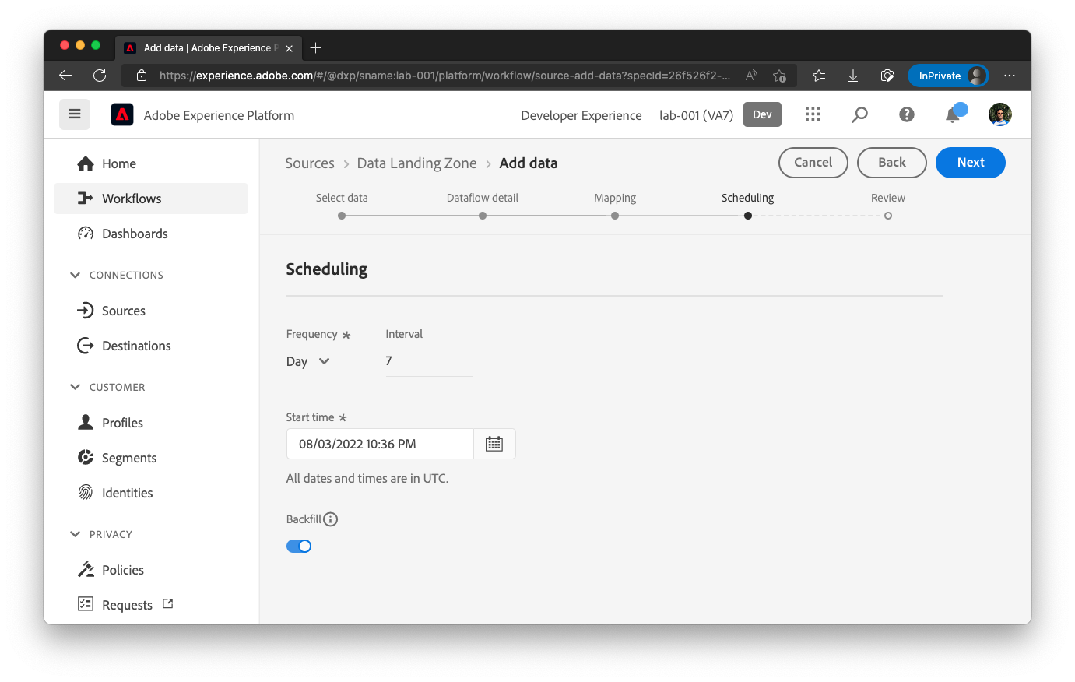

Review the data flow and click **Finish**.

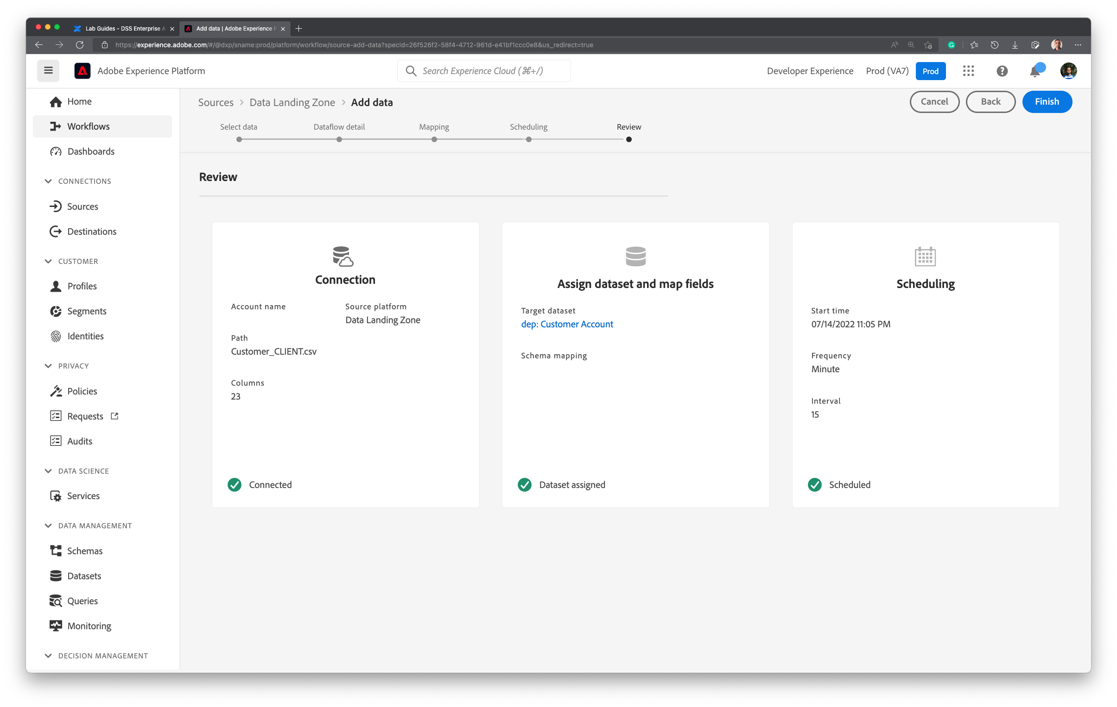

It takes few minutes to create the Dataflow. Once Dataflow is created, you will see the following screenshot. Notice that Last Dataflow Run Status indicates **No runs**. First run will kick off approximately in 15 minutes.

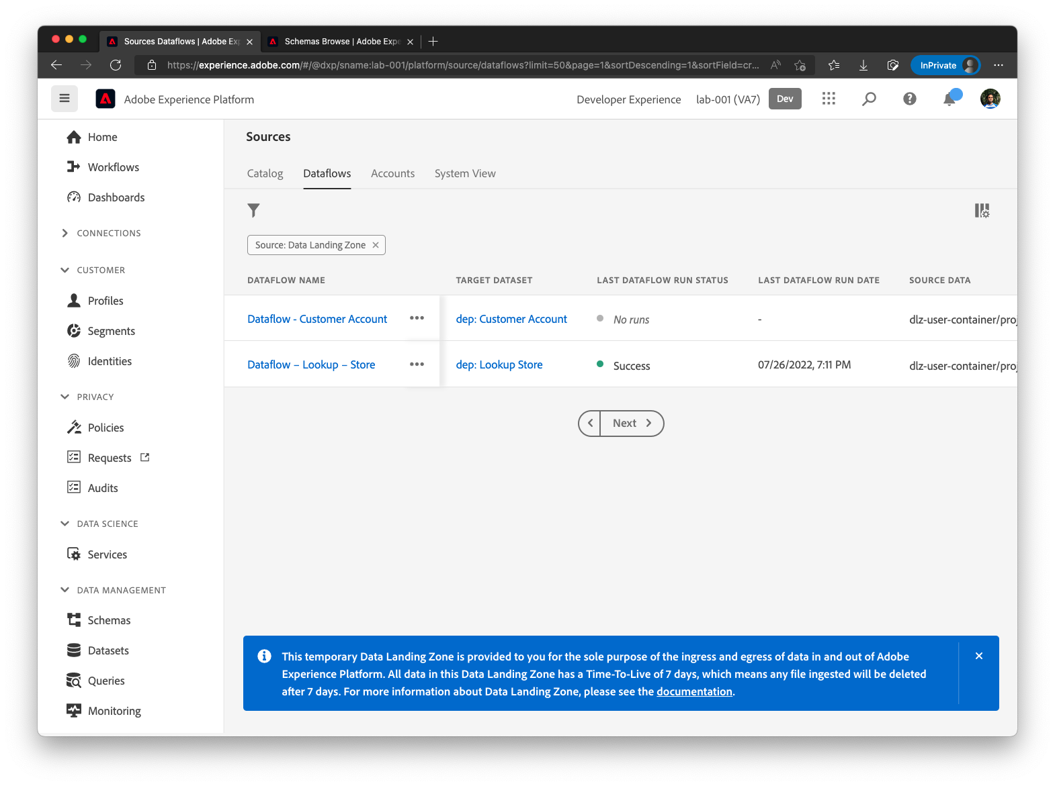

## Check scheduled execution

After 15 minutes, the following will appear. Notice the **Last Dataflow Run Status** and **Last Dataflow Run Date**.

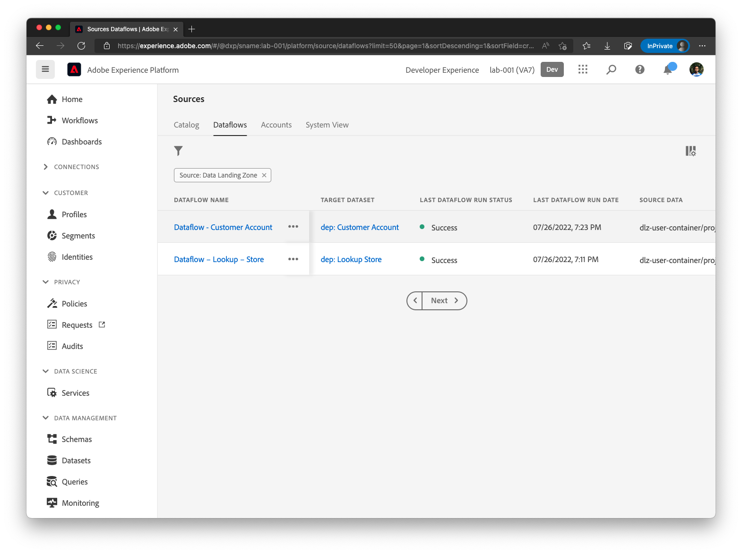

Click on the Dataflow name to get a list of Dataflow Runs. 10 Records should be ingested.

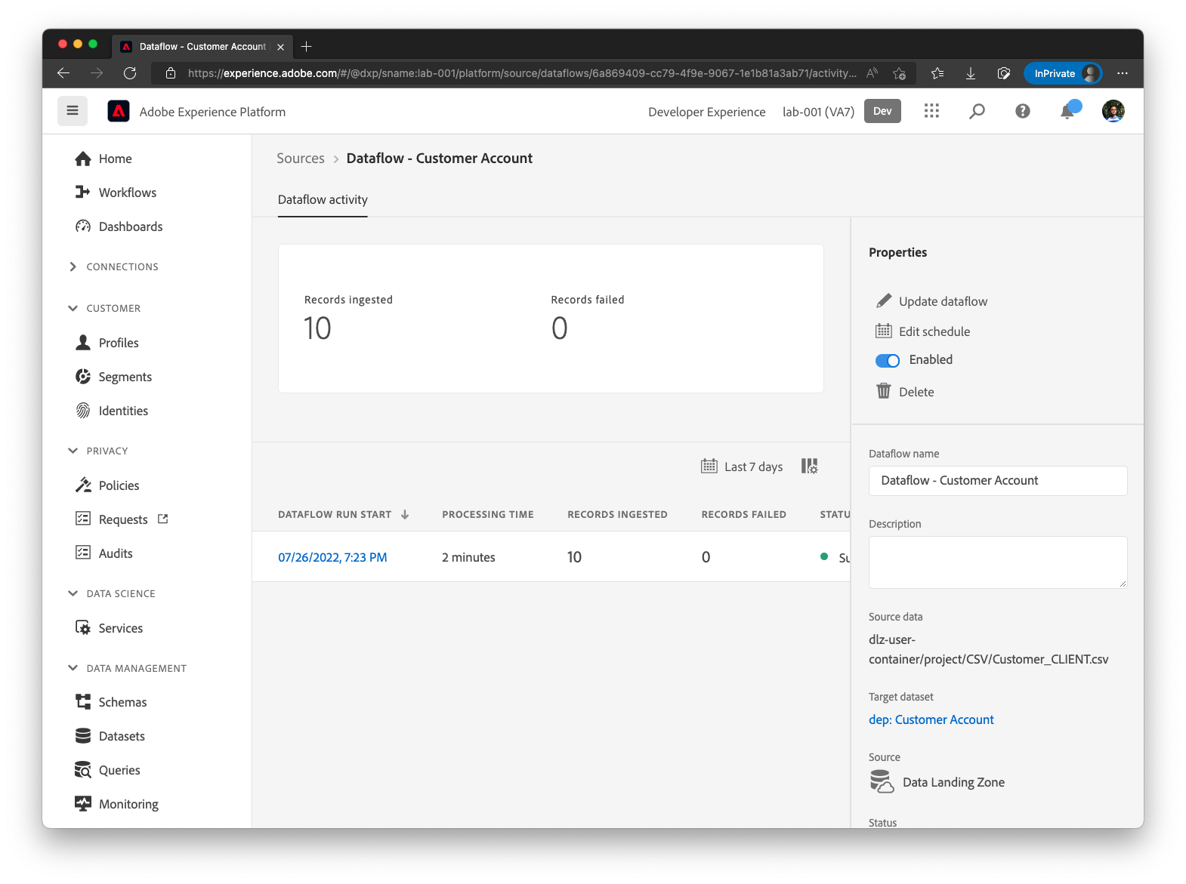

Click on the Dataflow Run Start time to see error diagnostic details.

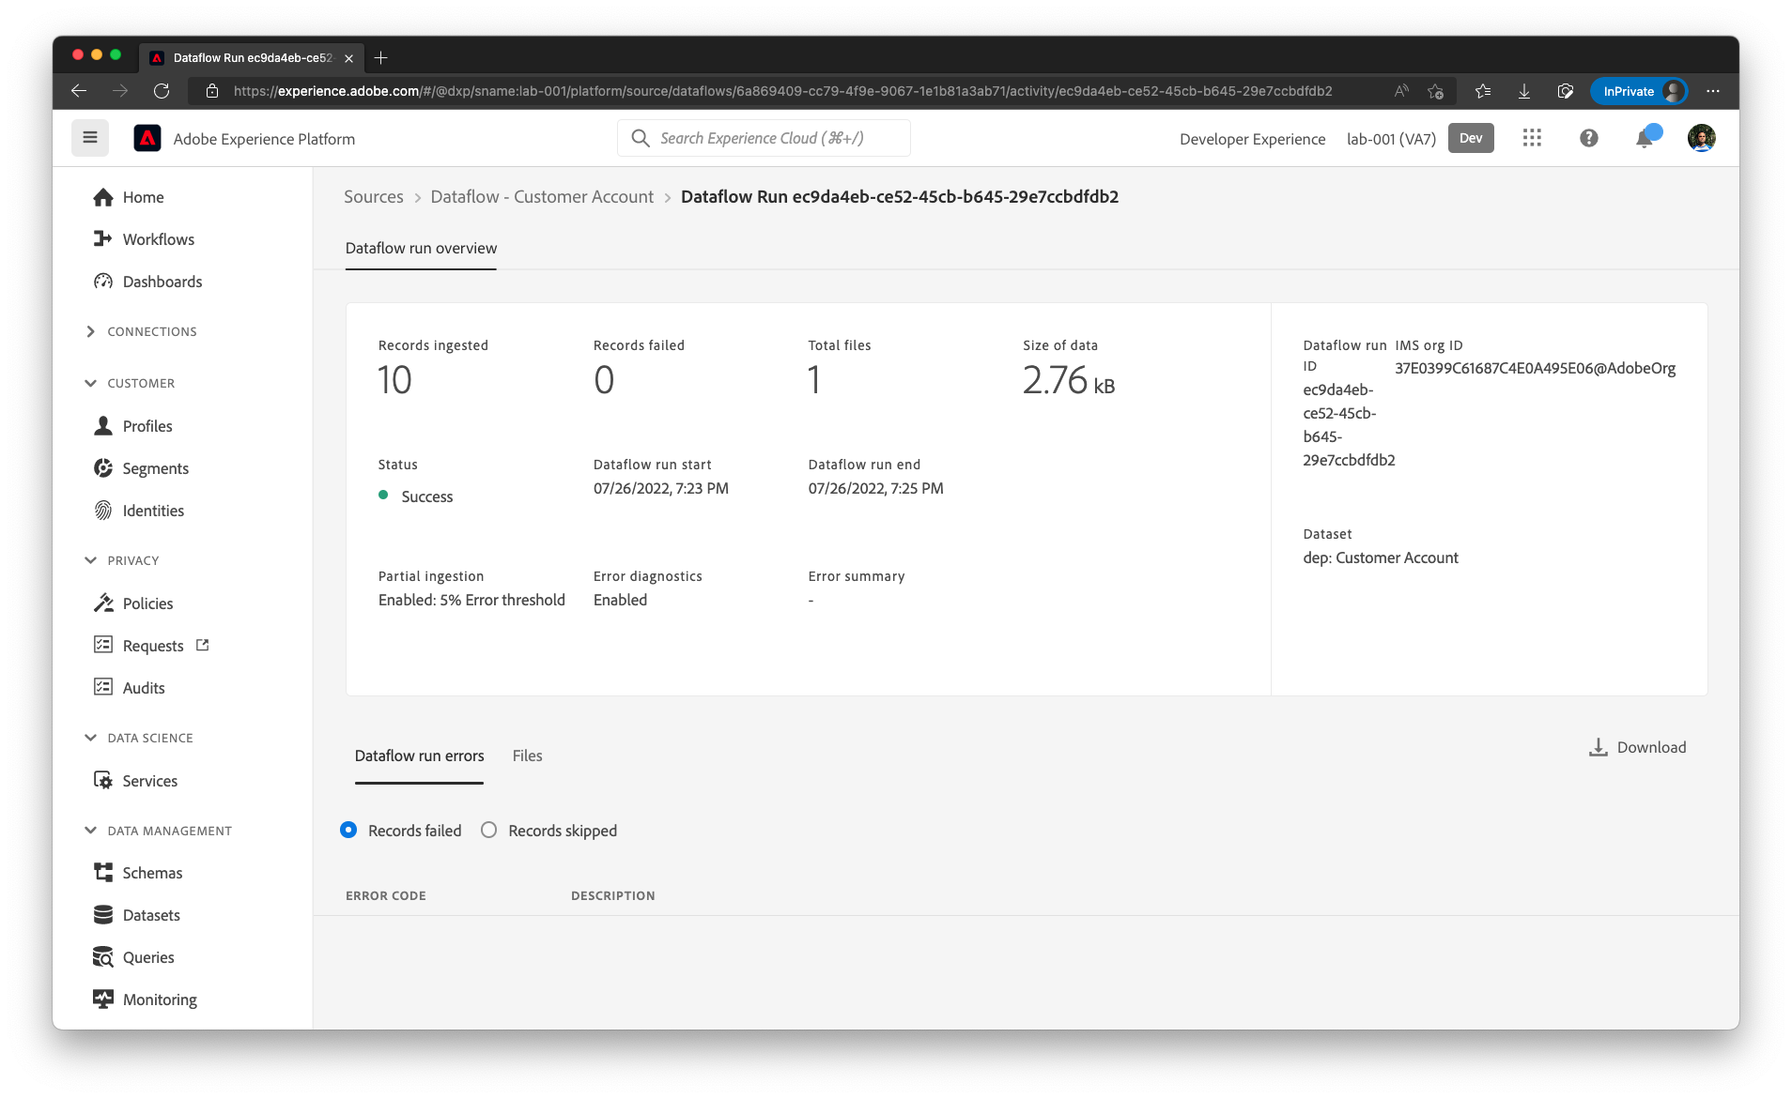

## Verify the data

In the Left Nav bar, Go to Datasets in Platform and click on **dep: Customer Account**

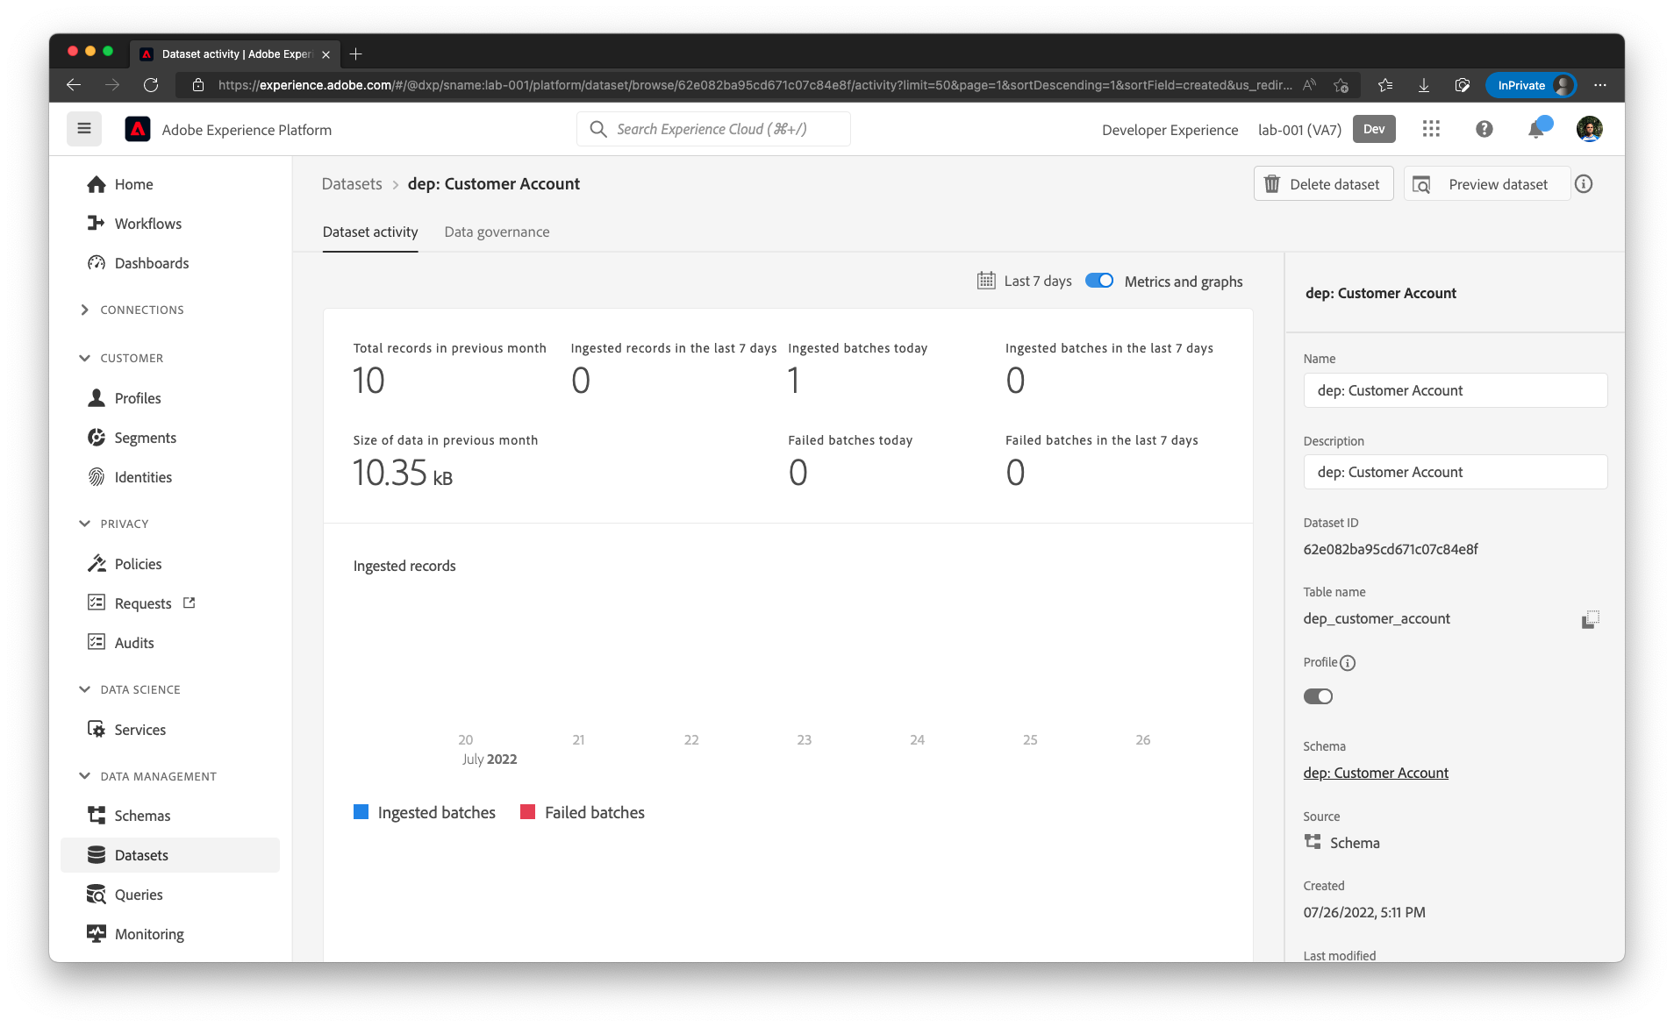

Click on the **Preview Dataset.** Notice there are no NULLs in the **consents.marketing.sms.val**.

